Has you seen my files?

Attack on a server utilising the haserl framework.
Difficulty: Hard
Ben Poulton
Abertay HackSoc Term 1 CTF 2025/26

Introduction
“Has you seen my files?” is a challenge centered around a web server utilising the Haserl CGI framework. This web server contains a page that has file listings, and a page that allows for the users to upload their own files, specifically to the /usr/local/usrfiles folder. By utilising file path traversal within the upload functionality, the user can upload their own haserl scripts to be run on the server, and therefore get access to flag.txt

Solution
An initial NMAP scan of the server shows a http service open on port 80. Navigating to the server’s IP address, they are shown a simple webpage with a hyperlink that states “View your files here”
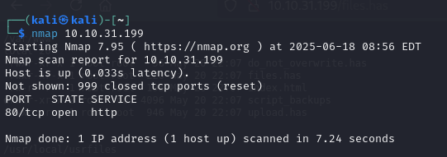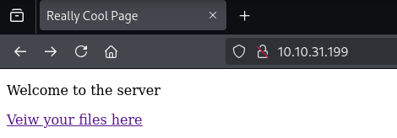
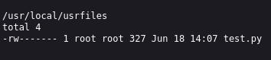
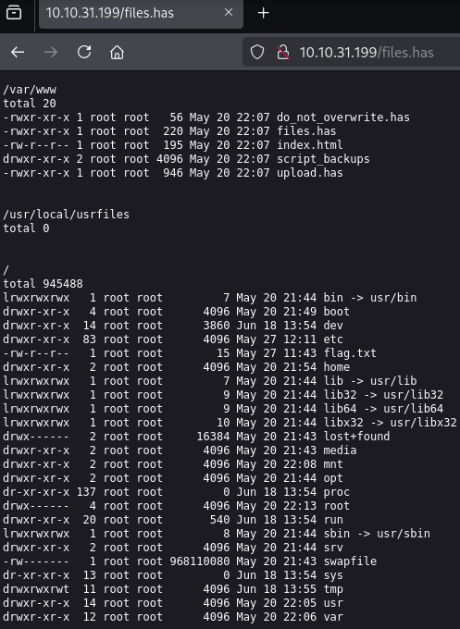
This link leads to the page files.has, which provides the user with the outputs of an ls -l command on the directories /var/www (web file location), /usr/local/usrfiles (user file location), and / (root directory)
Within the web directory, we can see index.html and files.has, which are the two pages that the user has already seen. The files do_not_overwrite.has and upload.has are new, as well as the folder script_backups.
do_not_overwrite.has simply contains a string “WORK IN PROGRESS”
upload.has contains a simple upload form that lets the user upload a file to the /usr/local/usrfiles directory, and shows a “upload finished” message on uploading a file. (This change is mirrored on files.has too)
There doesn’t seem to be any file type or content validation for files uploaded through this tool.
Running DIRB against the script_backups directory find files.txt, a file that seems to be the source code for files.has. The source code for all the other files can also be found within this directory, by simply replacing the .has extension with .txt, and checking out upload.txt reveals how the uploading feature is implemented, and that it is vulnerable to file path traversal.
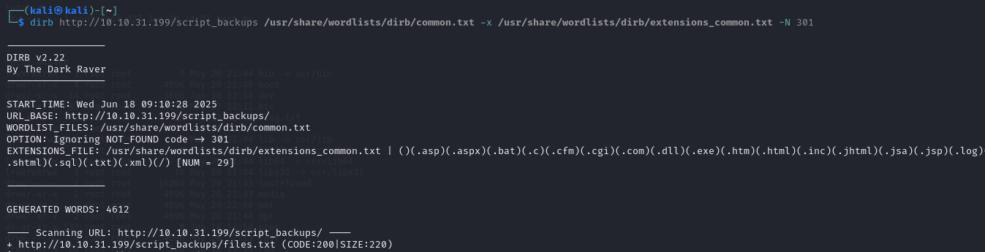

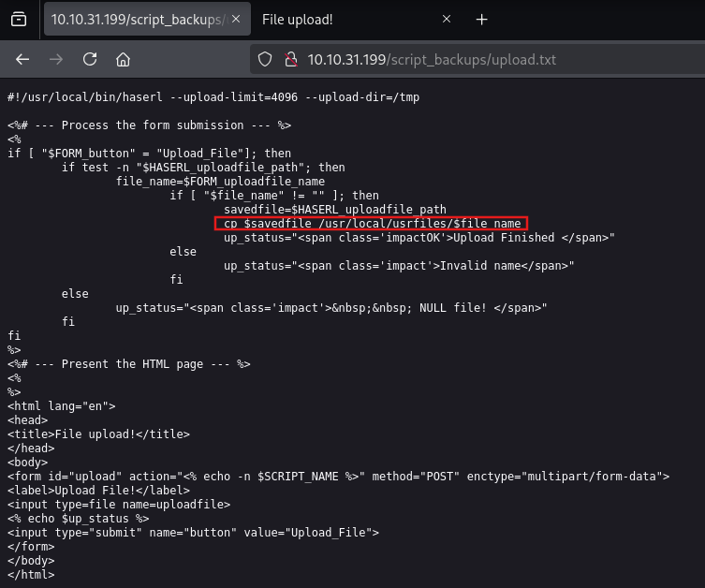
A bind shell script can be run using haserl, but regular reverse shell scripts will not work. Because the upload feature uploads to /usr/local/usrfiles with the permissions “rw-------”, a any haserl scripts uploaded will not be runnable, unless they overwrite an existing file. This is because when an existing file is overwritten, the permissions do not change.

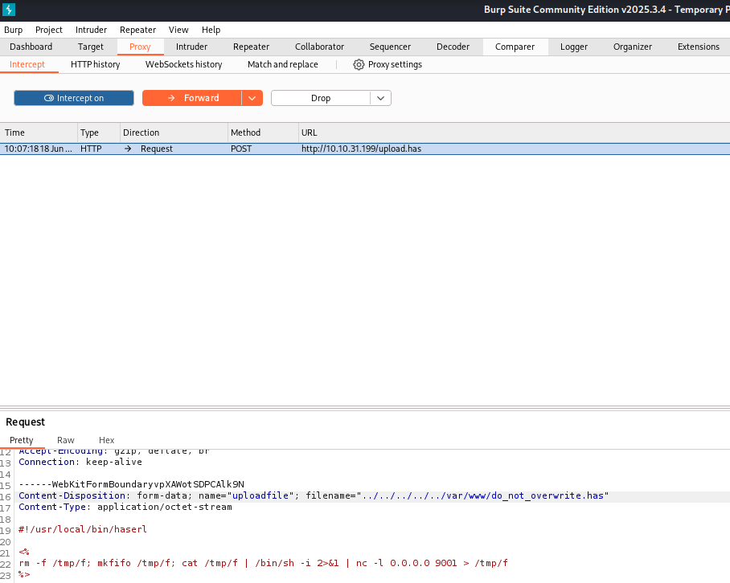
Changing the upload request using burp proxy to include path traversal characters in filename.
Accessing do_not_overwrite.has and then opening a nc connection to the now open port.
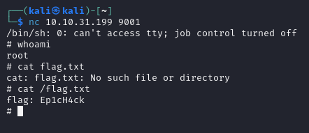
Note: A bind shell isn’t needed. A haserl script that simply runs “cat /flag.txt” would also give the same result.

